**Microsoft Azure Fundamentals (AZ-900)**

**What is meant by Azure Cloud?**

At its core, **Azure** is a public **cloud** computing platform – with solutions including infrastructure as a Service (**IaaS**), Platform as a Service (**PaaS)**, and Software as a Service (**SaaS**) that can be used for Services such as analytics, virtual computing, storage, networking, and much more.

**What is meant by Microsoft Azure?**

**Microsoft Azure,** commonly referred to as **Azure**, is a **cloud computing** service created by **Microsoft** for building, testing, deploying, and managing applications and services through Microsoft-managed **data centers.** It Provides SAAS, PAAS, IAAS and supports many different programming languages, tools, and frameworks, including both Microsoft-specific and third-party software and systems.

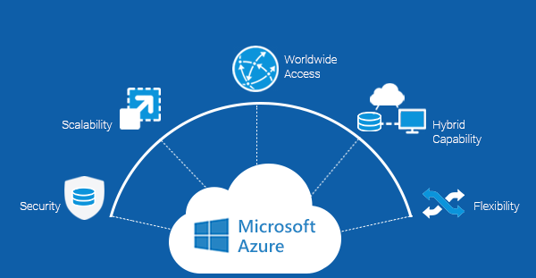

**Why do we need Microsoft Azure?**

**Storage.** Count on **Microsoft’s** global infrastructure to provide safe, highly accessible data storage. With massive scalability and an intelligent pricing structure that lets you store frequently accessed data a huge savings, building a safe and cost-effective storage plan **is** simple in **Microsoft Azure.**

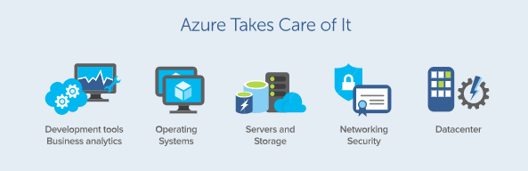

**Website:** [**https://azure.microsoft.com/**](https://azure.microsoft.com/)

**What is meant by Cloud Computing?**

**Cloud Computing** is the delivery of different services through the Internet. These resources include tools and applications like data storage, servers, databases, networking, and software. As long as an electronic devices has access to the web, it has access to the data and the software programs to run it.

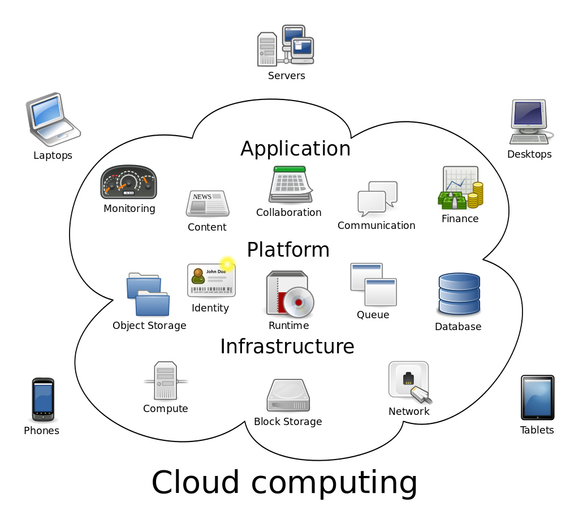

**Chapter 1: Describe Cloud Concepts (15-20%)**

**What is meant by Cloud Services?**

It refers to a wide range of **services** delivered on demand to companies and customers over the internet. These **services** are designed to provide easy, affordable access to applications and resources, without the need for internal infrastructure or hardware.

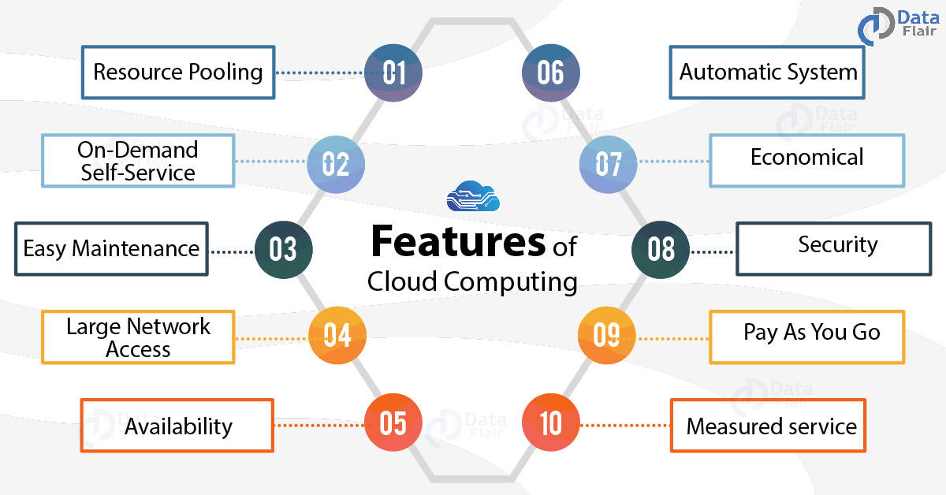

**What is meant by High Availability?**

**High Availability** is a quality of **computing** infrastructure that allows it to continue functioning, even when some of its components fail. … **Highly available** systems guarantee a certain percentage of uptime – for example, a system that has 99.9% uptime will be down only 0.1% of the time – 0.365 days or 8.76 hours per year.

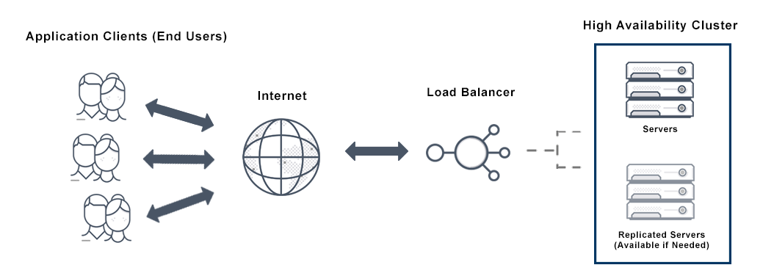

**Why we need High Availability?**

It is important for mission-critical systems. It permits the computing infrastructure to continue functioning, even when certain components fail.

It cannot tolerate interruption in service, and any downtime can cause damage or result in financial loss.

**Basic Elements of High Availability:**

**Redundancy:**

Ensuring that any elements critical to system operations have an additional, redundant component that can take over in case of failure.

**Monitoring:**

Collecting data from a running system and detecting when a component fails or stops responding.

**Failover:**

A mechanism that can switch automatically from the currently active component to a redundant component, if monitoring shows a failure of the active component.

**Technical Components of High Availability:**

**Data Backup and Recover:**

A System that automatically backs up data to a secondary location, and recovers back to the source. This can be used to set up redundancy and fail over.

**Load Balancing:**

A Load Balancer manages traffic, routing it between more than one system that can serve that traffic. The load balancer can be aware that one of the target systems has failed, and redirect traffic to another available system, thus implementing monitoring and failover.

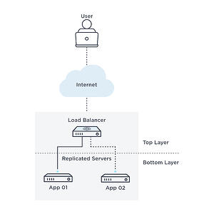

**Clustering:**

A Cluster contains several nodes that serve a similar purpose, and users typically access and view the entire cluster as one unit. Each node in the cluster can potentially failover to another node if failure occurs. By setting up replication within the cluster, you can create redundancy between cluster nodes.

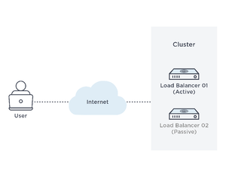

**What is meant by Scalability?**

It refers to the ability to increase or decrease IT resources as needed to meet changing demand. **Scalability** is one of the hallmarks of the **cloud** and the primary driver of its exploding popularity with businesses.

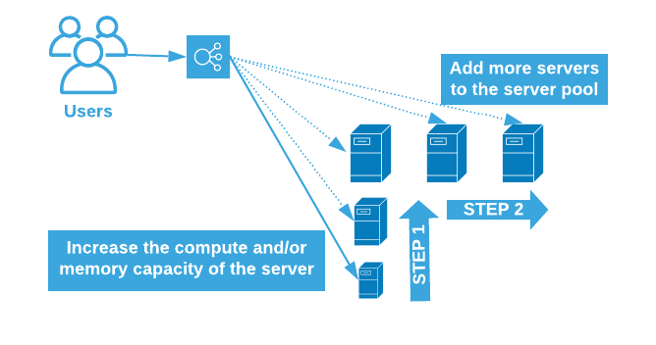

**Benefits of Scalability:**

Convenience: Just a few clicks, IT administrators can easily add more VMs that are available without delay – and customized to the exact needs of the organization. It Saves precious time for IT Staff.

Flexibility and Speed

Cost Savings

Disaster Recovery

**When to Use Cloud Scalability?**

If traffic or workload demand increase suddenly or grow gradually over time, a scalable cloud solution enables organizations to respond appropriately and cost-effectively to increase storage and performance.

**Types of Cloud Scalability:**

Two Types are available here.

* + Vertical Scaling
  + Horizontal Scaling

**Horizontal Scaling:**

We Scale by adding more machines into our pool of resources.

**When to Use Horizontal Scaling:**

Whenever a high availability of (sever) services are required.

**Common Use of HS:**

It involves adding more processing units or physical machines to your server or database. It involves growing the number of nodes in the cluster which reduces the responsibilities of each member node by spreading the key space wider and providing additional end points for client connections.

**Real time Uses of HS:**

The **Internet** and particular **Web Services** have boosted the use of **Horizontal Scaling.** Most giant companies that provide well knows web services like Google (Gmail, YouTube), Yahoo, Facebook, EBay, Amazon, etc. are using heavily horizontal scaling.

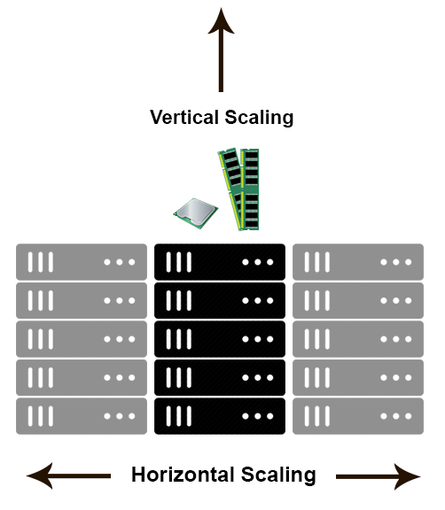

**Vertical Scaling:**

We Scale by adding more power **(CPU, RAM)** to the existing machine.

**Uses:**

**Vertical Scaling** used in applications and products of middle-range as well as small and middle-sized companies. The Common Example of **Virtual Scaling** is to buy an expensive hardware and use it as a Virtual Machine Hypervisor (VMWare ESX).

**Why Vertical Scaling Needed:**

It means upgrading of server hardware. It Includes IOPS (Input / Output Operations), amplifying CPU/RAM capacity, as well as disk capacity.

**Difference in Horizontal Vs Vertical Scaling:**

Horizontal Scaling is often based on partitioning of the data in which each node contains only part of the data.

Vertical Scaling, the data resides on single node. Scaling here is done through multi-core by spreading the load between the CPU and RAM Resources.

**Which Scaling is Feasible?**

Horizontal Scaling is quite easy as you can add more machines into the existing pool.

Vertical Scaling is often limited to the capacity of a single machine.

**Examples:**

**Horizontal Scaling:** Cassandra, MongoDB

**Vertical Scaling:** MySQL

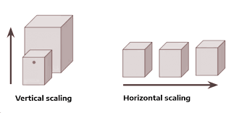

**What do you mean by Elasticity in Cloud Computing?**

It refers to the dynamic allocation of **cloud** resources to projects, workflows, and processes. In the **cloud,** it’s the system by which **cloud** vendors provide the exact amount of resources an enterprise needs to run something.

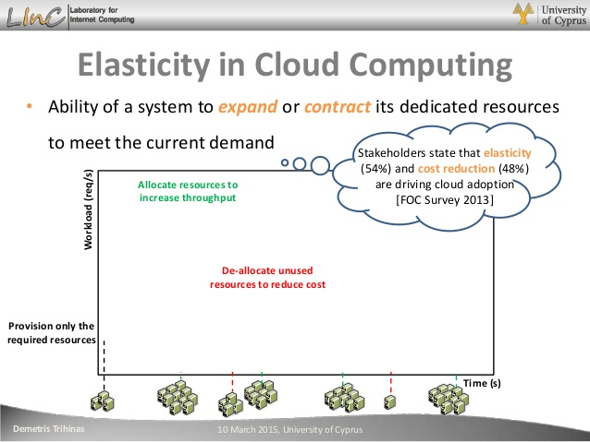

If user needs more resources (systems or services), the cloud services automatically increases the systems/services. Otherwise, if the user need is in downtime, the cloud services automatically reduces the systems/services without the services interruption.

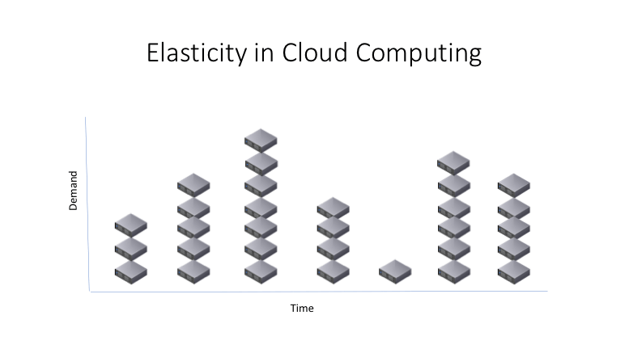

**Benefits of Cloud Elasticity:**

* On Demand Computing
* Pay Only for What you Use
* Failover and Fault Tolerance
* Common Coding
* Ease of Implementation

**Challenges in Elastic Cloud:**

* Learning Curve (It take 6 months to a year to become efficient in a specific provider’s cloud technology)
* Security
* Privacy and Compliance

**Types of Elasticity:**

Horizontal Elasticity

Vertical Elasticity

**Horizontal Elasticity:**

It Consists in adding or removing instances of computing resources associated with an application.

**Vertical Elasticity:**

It Consists in increasing or decreasing characteristics of computing resources, such as CPU times, cores, memory, and network bandwidth.

**What do you mean by Agility in Cloud Computing?**

Cloud Agility means rapid provisioning of computer resources using cloud computing. It shows that, today, more and more global enterprises and large-scale businesses are moving to the **cloud** to save cost and time.

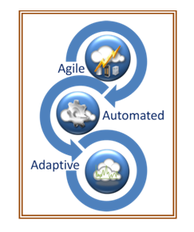

Agility is built on Microsoft **Azure**. **Agility and Azure** help companies focus on innovating their core business offerings, not managing servers and hardware.

The ability to rapidly develop, test and launch software applications that drive business growth. **Cloud Agility** allow them to focus on other issues such as security, monitoring and analysis, instead of provisioning and maintaining the resources.

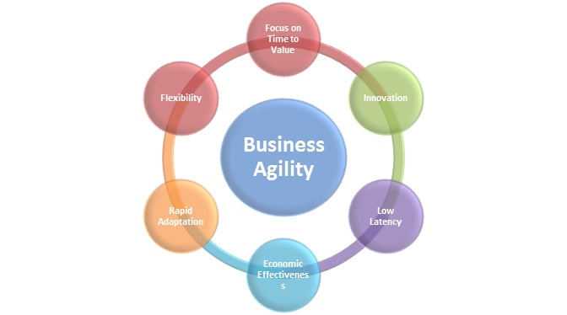

**Cloud Agility Offers Greater Scalability:**

Organizations can dramatically drive down the costs of product experimentation and testing while reducing risk, enabling them to further reduce their time-to-market for new products, features and enhancements.

**Why Cloud Agility is More Important in business?**

The **cloud** enables **business agility** by reducing **business** complexity. This is achieved by simplifying internal operations and enabling greater automation. The **cloud** also simplifies the management of IT resources.

**Benefits of Cloud Agility:**

* Quicker Time-to-market (Quick Time to market for your Applications)
* Automated Allocation of Resources
* Flexibility and Scalability and High Availability
* Adaptive Auto-Scaling
* Faster Innovation
* Faster upgrades of the software
* Better Skill sets for all aspects of your business
* Better Access to Quality and tested software

**What do you mean by Fault Tolerance in Cloud?**

It refers to the ability of a system (computer, network, **cloud** cluster, etc.). to continue operating without interruption when one or more of its components fail. **Fault-tolerant** systems use backup components that automatically take the place of failed components, ensuring no loss of service.

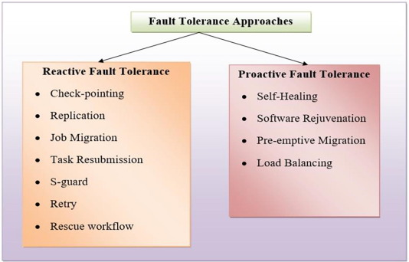

**Benefits of Fault Tolerance:**

* Failure Recovery
* Simple Hardware Platform
* Independent from Application
* High in Reliability
* Lower Cost
* Improved Performance Metrics
* Strength of Stored Data

**Types of Faults:**

1. **Network Fault:** A Fault occur in a network due to network partition, Packet Loss, Packet Corruption, Destination Failure, Link Failure, etc,.
2. **Physical Fault:** It can occur in Hardware like Fault in CPUs, fault in memory, fault in Storage, etc,..
3. **Media Fault:** It Occurs due to Media Head Crashes.
4. **Processor Fault:** It Occurs in Processor due to Operating System Crashes, etc,..
5. **Process Fault:** It Occurs due to shortage of resource, software bugs, etc,.
6. **Service Expiry Fault:** The Service time of a resource may expire while application is using it.

**What do you mean by Disaster Recovery in Cloud Computing (Cloud DR)?**

It entails storing critical **data** and applications in **cloud storage** and failing over to a secondary site in case of a **disaster. Cloud Computing Services** are provided on a pay-as-**you-**go basis and **can** be accessed from anywhere and at any time.

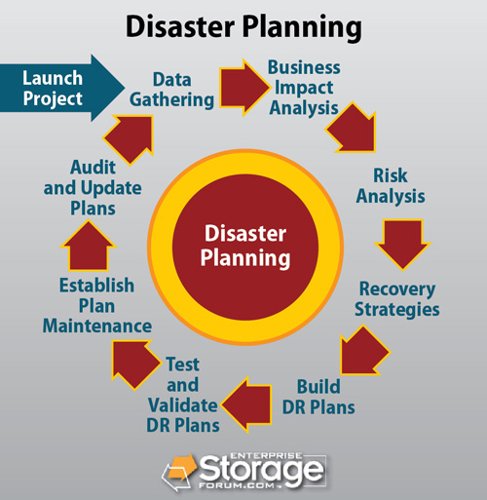

**How Disaster Recovery Works in Cloud Computing?**

Creating, testing, and updating a DR Plan can prepare your organization for an unexpected disaster and ensure safety and continuity for your business. It should take into account your infrastructure, potential threats and vulnerabilities, most critical assets and the order of their recovery, and workable DR strategies.

**Benefits of Cloud Disaster Recovery (CDR):**

* Faster Turnaround Time
* Minimal Downtime Expense
* Less Complexity

**Successful Disaster Recovery Plan Should Include the following:**

* Programs vs. data
* Crucial Programs
* Dependencies
* Key Personnel
* Security and Compliance
* An RTO (Recovery Time Objective) should be set
* An RPO (Recovery Point Objective) should be determined.

**Types of Disaster Recovery:**

* Data Center Disaster Recovery
* Cloud-Based Disaster Recovery
* Virtualization Disaster Recovery
* Disaster Recovery as a Service

**Describes the Principle of Economies of Scale in Azure?**

It is the ability to do things more efficiently or at a lower-cost per unit when operating at a larger **scale** (e.g. the ability to acquire hardware at a lower cost than if a single user or smaller business were purchasing it, cloud providers can also make deals with local governments and utilities to get tax savings, lower pricing on power, cooling, and high-speed network connectivity between sites.

**What is meant by Capital Expenditure (CapEx) ?**

The funds used by a company to acquire, upgrade, and maintain physical assets such as property, plants, buildings, technology, or equipment. **CapEx** is often used to undertake new projects or **investments** by a company.

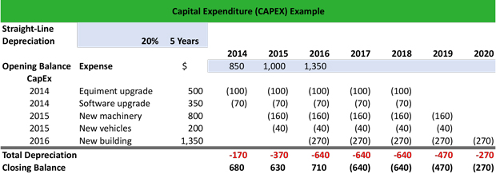

**What is meant by Operational Expenditure (OpEx)?**

An **Operating Expense, Operating Expenditure, Operational Expense, Operational Expenditure or Opex** is an ongoing **cost** for running a product, business, or system, its counter part, a **capital expenditure** (capex), is the **cost** of developing or providing non-consumable parts for the product or system.

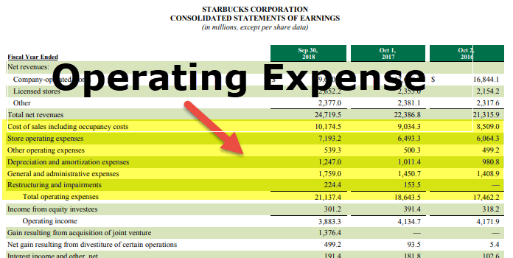

**Diff between OPEX and CAPEX:**

An **Operating Expense (OPEX)** is an expense required for the day-to-day functioning of a business. In Contrast, **a Capital Expense (CAPEX)** is an expense a business occurs to create a benefit in the future.

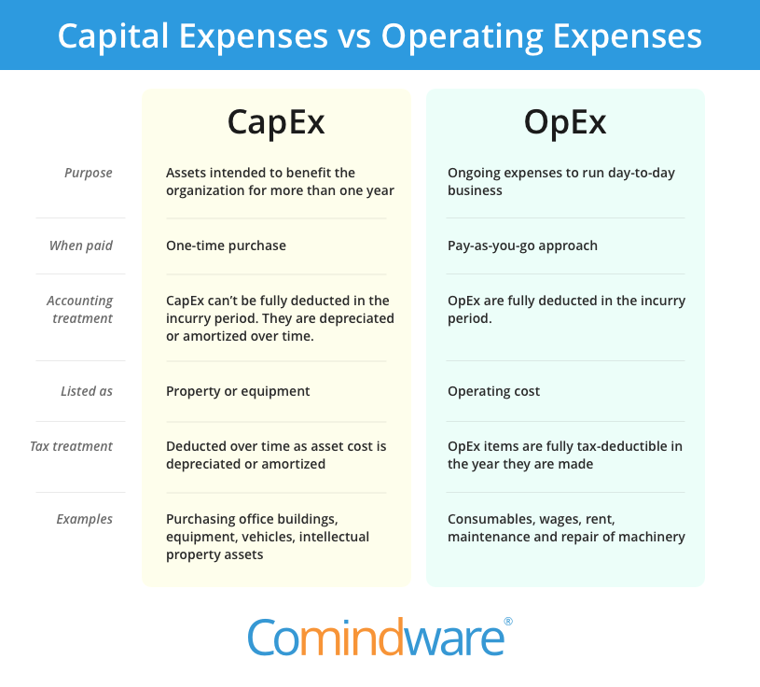

**What is meant by Consumption Based Model?**

A **consumption-based** pricing **model** is a service provision and payment scheme in which the customer pays according to the resources used. This **model** is essentially the same as the utility computing payment structure and those of other utilities, such as water and electricity.

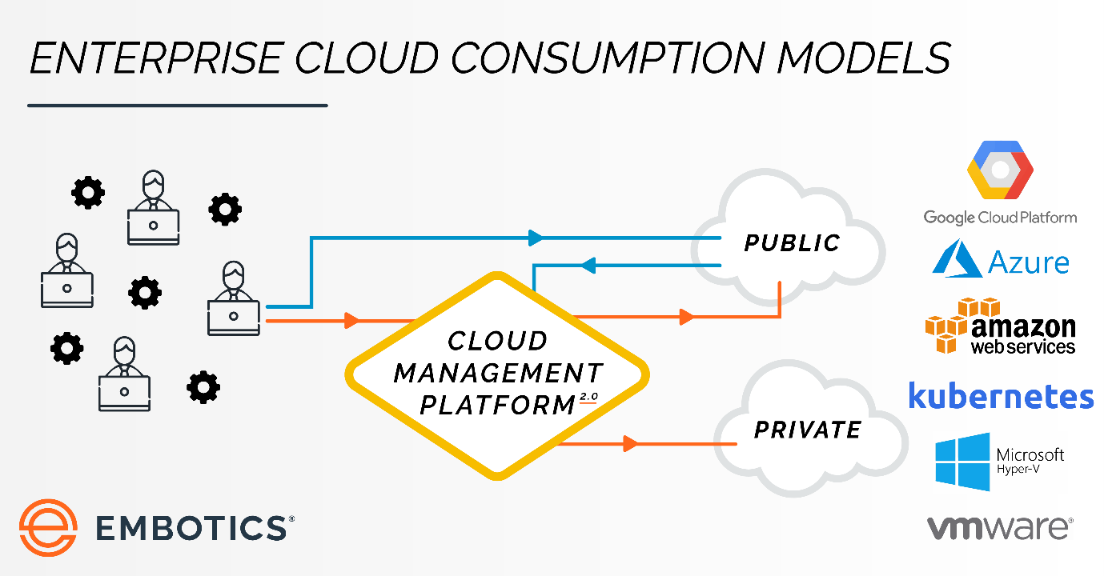

**What is meant by IaaS (Infrastructure as a Service)?**

It is an instant computing infrastructure, provisioned and managed over the internet. It helps you to avoid the expense and complexity of buying and managing your own physical servers and other Data Centre Infrastructure.

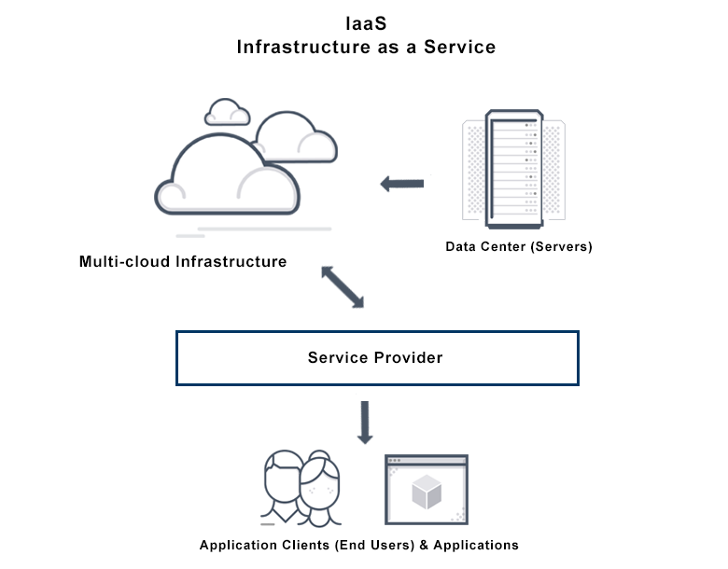

It is one of the four types of cloud services, along with Software as a Service (**SaaS)**, Platform as a Service (**PaaS)** and **serverless.**

**IaaS** quickly scales up and down with demand, letting you pay only for what you use. It helps you avoid the expense and complexity of buying and managing your own physical servers and datacentre infrastructure.

Each resource is offered as a separate service component and you only need to rent a particular one for as long as you need it. A **cloud computing service provider**, such as **Azure**, manages the infrastructure, while you purchase, install, configure and manage your own software – operating systems, middleware and applications.

Users can run any operating system or applications on the rented servers in geographic locations close to their end users. IaaS automatically scales, both up and down, depending on demand and provides guaranteed **Service-Level Agreement (SLA)** both in terms of uptime and performance. It eliminates the need to manually provision and manage physical servers in data centers.

**What is PaaS (Platform as a Service) ?**

Platform as a Service (PaaS) is a complete development and deployment environment in the cloud, with resources that enable you to deliver everything from simple cloud-based apps to sophisticated, cloud-enabled enterprise applications.

PaaS allows you to avoid the expense and complexity of buying and managing software licenses, the underlying application infrastructure and middleware, container orchestrators such as Kubernetes or the development tools and other resources.

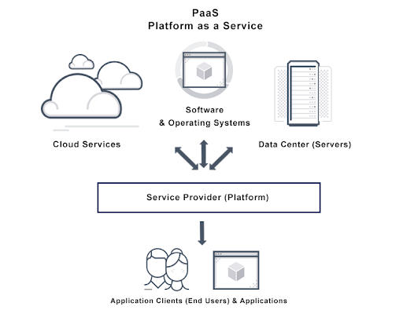

**What is meant by SaaS (Software as a Service):**

Software as a Service (or **SaaS**) is a way of delivering applications over the Internet – as a Service. Instead of installing and maintaining software you simply access via the Internet, freeing yourself from complex software and hardware management.

**Software as a Service (SaaS)** (also known as **subscribeware** or **rentware** ) is a software **licensing** and **delivery** model in which **software** is licensed on a **subscription** basis and is centrally **hosted.** It is sometimes referred to as “on-demand-software”, and was formerly referred to as “Software Plus Services” by **Microsoft.**

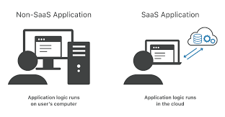

**Difference Between IaaS, PaaS And SaaS:**

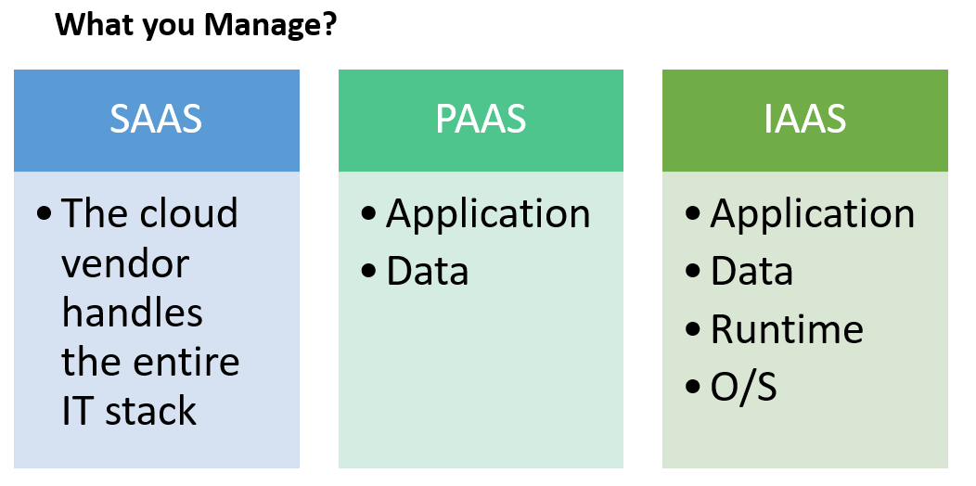

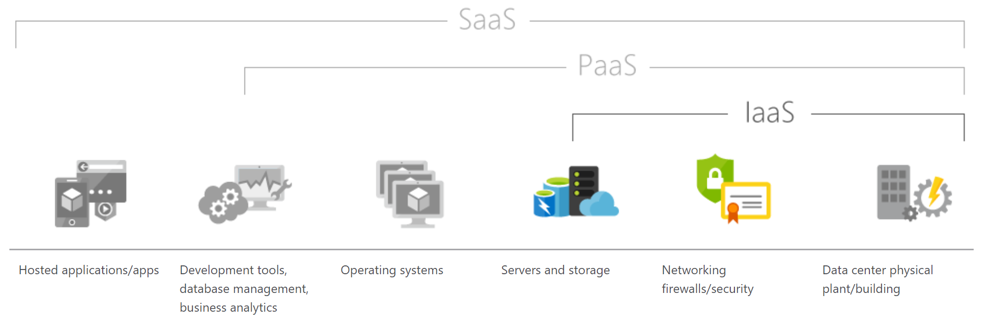

|  |  |
| --- | --- |
| **Platform Type** | **Common Examples** |
| **SaaS** | Google Workspace, Dropbox, Salesforce, Cisco WebEx, Concur, GoToMeeting |
| **PaaS** | AWS Elastic Beanstalk, Windows Azure, Heroku, Force.com, Google App Engine, Apache Stratos, OpenShift |
| **IaaS** | DigitalOcean, Linode, Rackspace, Amazon Web Services (AWS), Cisco Metapod, Microsoft Azure, Google Compute Engine (GCE) |

**Top Advantages of IAAS:**

**Scalability:**

IaaS quickly scales up and down-on-demand, letting you pay only for what you use. IaaS is the most flexible cloud computing model. For Instance, as soon as you decide to launch a new product or application, the necessary computing infrastructure can be ready within minutes or hours.

**Cost-efficient:**

It can be economic option for start-ups or enterprises testing new ideas because it eliminates the upfront expense of buying hardware outright and managing an on-premise data center. Furthermore, resources can be purchased as needed, letting you pay for only what you use. For Instance, IaaS is an effective model for experimental applications. Organizations can host and test the application using an IaaS Provider, then refine it or go in a different direction without having to take on the full cost and responsibility of purchasing and maintaining onsite data centers.

**What is meant by Public Cloud?**

A **Public Cloud** is a type of computing in which a service provider makes resources available to the **public** via the internet. Some **public cloud** providers offer resources for free, while clients pay for other resources by subscription or a pay-per-usage model.

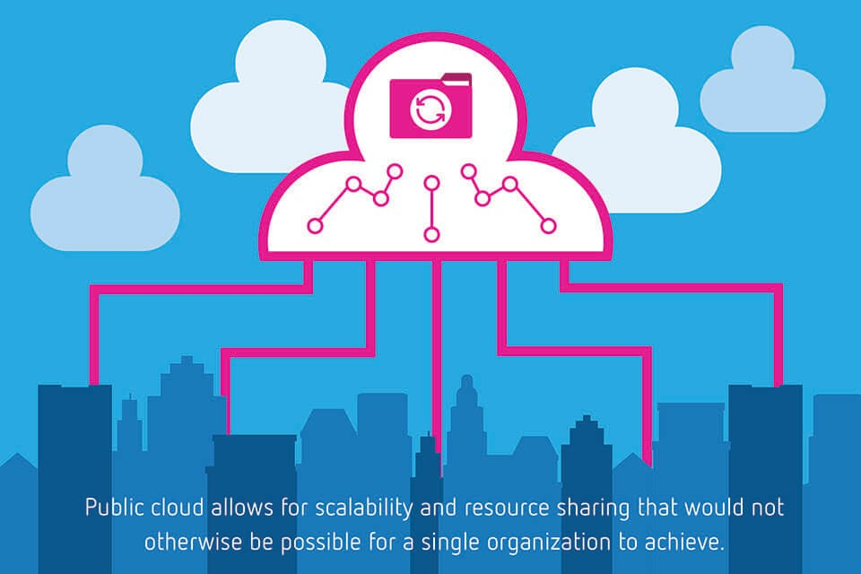

**Characteristics of Public Cloud:**

Ultimate **Scalability –** vast on demand resources are available so that applications can respond seamlessly to fluctuations in activity. **Cost** effective – public cloud brings together a greater level of resources so users can benefit from the largest economies of scale.

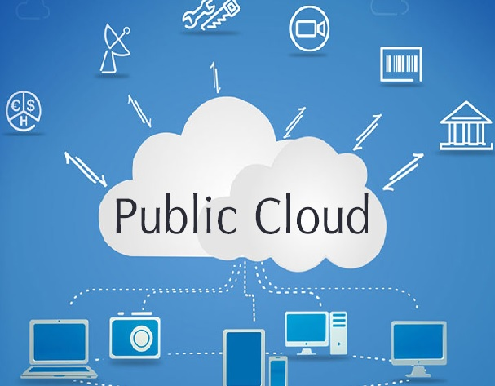

**Advantages (or) Benefits of Public Cloud:**

* Lower Costs- No need to purchase hardware or software.
* Pay only for the service you use.
* No maintenance – Your Service Provider provides the maintenance.
* Near-unlimited scalability-on-demand resources are available to meet your business needs.
* Improve Security
* Save Time and Money
* Free up IT Talent

**When Should I Use the Public Cloud?**

The **Public cloud** is most suitable for these types of environments: Predictable computing needs, such as communication Services for a specific number of users. Apps and services necessary to perform IT and business operations. Additional resource requirements to address varying peak demands.

**Difference between Public Vs Private Cloud:**

